**MINI-PROJECT REPORT**

Bus Reservation System



# NAME: - Kommalapati Sowmya

**TABLE OF CONTENTS**

|  |  |
| --- | --- |
| **SERIAL No.** | **CONTENT** |
| 1 | Introduction |
| 2 | Objective |
| 3 | Features |
| 4 | 4 W’s 1H |
| 5 | SWOT Analysis |
| 6 | Requirements |
| 7 | Architecture |
| 8 | Use case diagram |
| 9 | Expected results/Outcomes |

# Introduction:

“Online Bus Reservation System” is windows based application that works within centralized network.The software program “Online Bus Reservation System” provides bus transportation system, a facility to reserved seats, cancellation of seats and different type of enquiry which need on instant and quick reservation.OBTRS is built for manage and computerized the traditional database, ticket booking and tracking bus and travel made easy. It maintains all data of users, bus details, reservation details, booking details, customer details.

# Objective:

The main objective of the project entire to automate the ticket booking process of day to day activities of system library like:

1. Ticket activities
2. Creation of a Customer ID.
3. Assign a bus ticket according to customer’s demand.
4. Advance booking
5. Bus ticket Cancellation
6. Feedbacks

# Benefits:

1. Online booking system save your staff time.
2. Removing the bottleneck of phone booking system.
3. Greater sales and marketing synergy.
4. A modern approach to booking.
5. Increased revenue thanks to upselling.
6. Can come at a cost.
7. Requires internet access.

# Features:

1. System setting management.

2.Online ticket booking.

3.Real Time booking system.

4.Booking cancel Request.

5.Easy to sign up/sign in.

6.Trip Management.

7.Profile Management.

8.Agent Management.

9**.**Admin Dashboard.

WHO:This Bus Reservation System is an application is used by the all the public.

WHAT:The Online Bus Ticket Reservation System is a web based application that allows visitors check bus ticket availability, buy bus ticket and pay the bus ticket online. This system is established for all the home/office users after gaining access from the administrator.

WHERE:The Bus Reservation System is nowadays essential for every one from kids to grandparents and anywhere we use theses software application .They can use this software as the purpose of booking cancellation of tickets.

WHEN:This Bus Reservation System is very useful wherever we have we can easily book a ticket by using our mobile phone or something else.These software will solve so may of problems like standing on line in bus stand for hour and hour by these process we can easily book a ticket.

HOW:This project is implemented to do the book a ticket, cancellation of ticket and to implement easy process to the people.

# SWOT Analysis

# Strengths:

1.Advantages of the organization.

2.Activities of the company better than competitors.

3.Unique resources and low cost resources company have.

4.Activities and resources market sees as the company’s strength.

5.Unique selling proposition of the company.

**WEAKNESS:**

1.Improvement that could be done.

2.Activities that can be avoided for Online Bus Reservation System.

3.Activities that can be determined as your weakness in the market.

4.Factors that can reduce the sales.

5.Competitor’s activities that can be seen as your weakness.

**OPPORTUNITIES:**

1.Good opportunities that can be spotted.

2.Opportunities for Online Bus Reservation System can be obtained form things such as;

3.Change in technology and market strategies.

4.Government policy changes that is related to the company’s field.

5.Changes in social pattern and lifestyles.

6.Local events.

**THREATS:**

1.Company facing obstacles.

2.Activities of competitors.

3.Product and services quality standards.

4.Threat from change in technologies.

5.Financial/cash flow problems.

6.Weakness that threaten and that business.

# REQUIREMENTS



**High Level Requirements:-**



| **ID** | **DESCRIPTION** | **CATEGORY** | **STATUS** |
| --- | --- | --- | --- |
| HR01 | Every online booking needs to be associated with an account | Functional | In progress |
| HR02 | One account cannot be associated with multiple users | Functional | In progress |
| HR03 | Search should be enable users to find the most recent and relevant booking options | Functional | In progress |
| HR04 | System should enable users to book | Functional | In progress |
| HR05 | System should only allow user to move to payment only when mandatory field such as date, time, location | Functional | In progress |
| HR06 | System should consider time zone synchronization when accepting bookings from different time zones | non functional | In progress |
| HR07 | Booking confirmation should be sent to user to the specified contact details | non functional | In progress |

# Low Level Requirements:-



| **ID** | **DESCRIPTION** | **HLR ID** | **STATUS** |
| --- | --- | --- | --- |
| LR01 | Use of captcha and encryption to avoid bus from booking tickets | HR01 | In progress |
| LR02 | Search results should populate within acceptable time limits | HR02 | In progress |
| LR03 | User should be helped approximately to fill in the mandatory fields, inaces of invalid input | HR03 | In progress |
| LR04 | System should accept payments via different payments methods, like PayPal, wallets, cards,etc | HR04 | In progress |
| LR05 | System should visually confirm as well send booking confirmation to the user's contact | HR07 | In progress |

**Architecture:**

**USE CASE DIAGRAM:-**

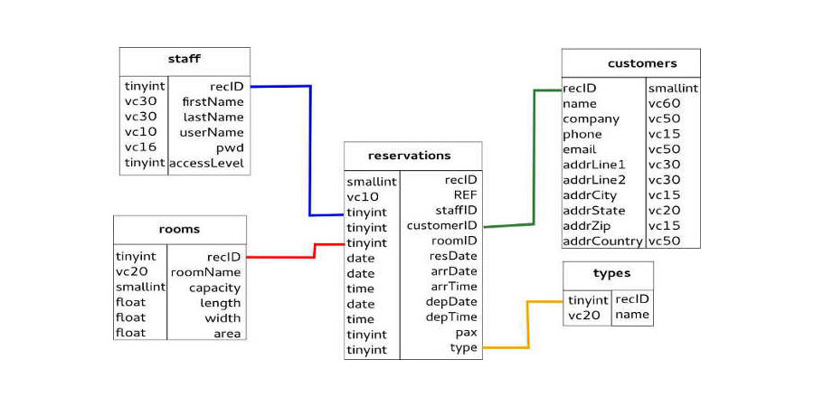

# CLASS DIAGRAM:-

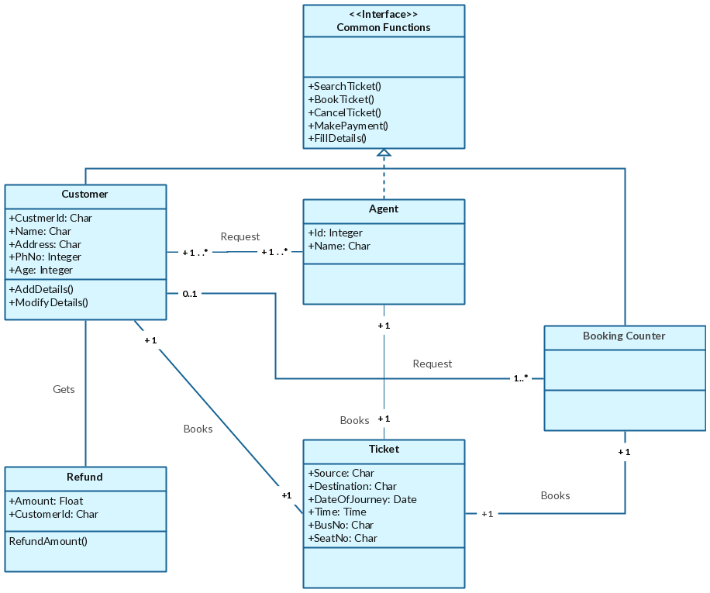

**STATE DIAGRAM:-**

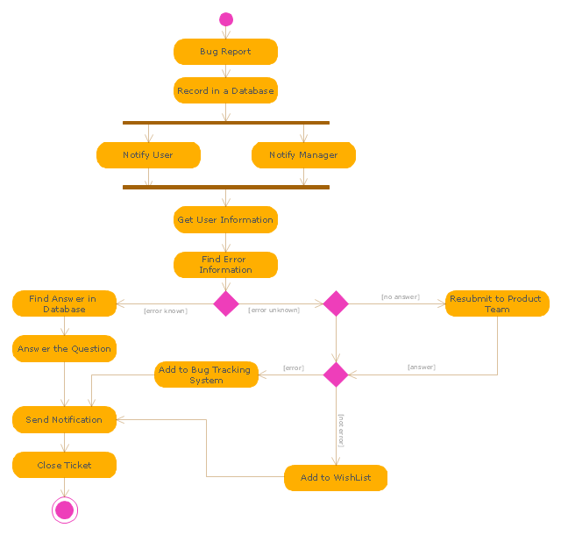

**SEQUENCE DIAGRAM:-** 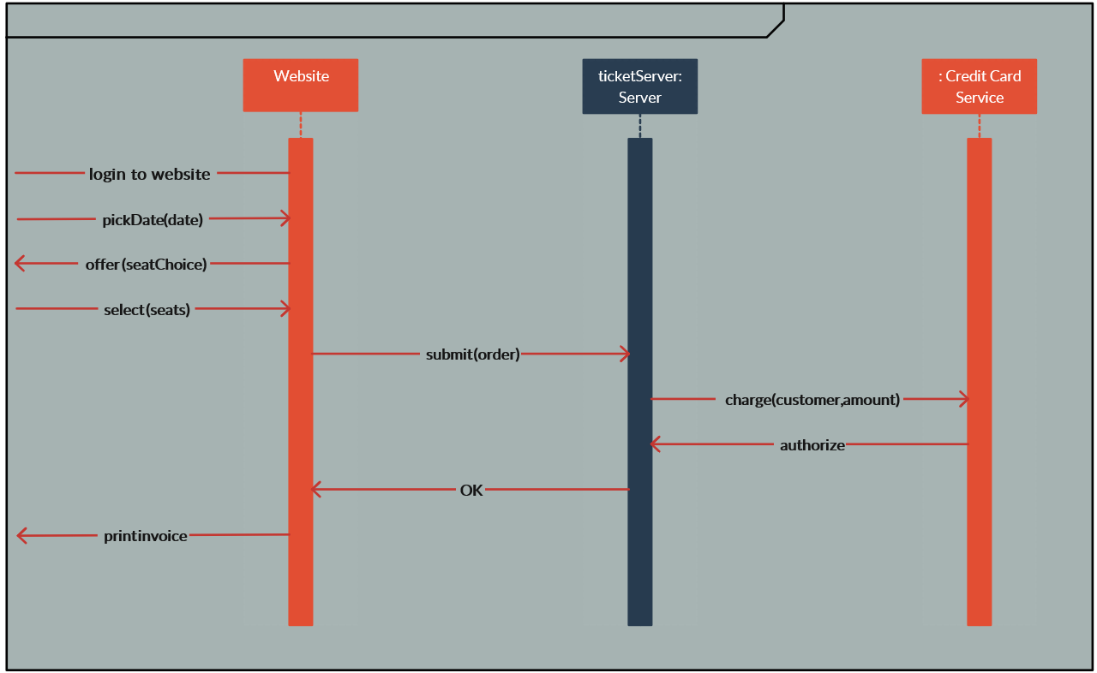

**Output Images:**

